

**UK / EU DECLARATION OF COMPLIANCE**

PFF Health, Unit 3, Airedale Park, Royd-Ings Avenue, Keighley, West Yorkshire, BD21 4BZ United Kingdom

Product Description - Apron Polythene White 686 x 1170mm, 16 micron, NON Sterile.

Product Code - PHA001W

Classification - Class 1 PPE Minimal Risk

PPE products (Aprons) supplied by PFF Health comply with the Essential Health and Safety Requirements and are designed to be liquid resistant and prevent the transfer of fluids.

We seek documented assurance from all our raw material suppliers that all materials supplied are compliant with relevant EU and UK legislation including but not restricted to all listed in this document

All films are wholly manufactured in the UK, typically using materials sourced from approved suppliers in the UK.

This declaration is issued under the sole responsibility of the of the manufacturer (PFF Health), and remains valid until such time as legislation, process change, enhanced understanding or knowledge becomes apparent, or our customers require it.

1. **General Statement:**

The aprons (“**16-micron polythene apron**”)

Are in conformity with the provisions the minimum requirements that are set within applicable regulation and BS, EN, ISO standards, includingbut not restricted to the following:

* **Regulation (EU) No. 2016/425** on personal protective equipment and repealing Directives 89/686/EEC.

Conformity is assessed using the test methods, includingbut not restricted to the following:

* **ISO 4593:1993 Dimensional properties –** Spot thickness
* **BS 2782:6 / ISO 4591 –** Gravimetric thickness
* **BS EN ISO 7765-1:2004 – Impact strength**
* **ISO 6383-2:2004 –** Tear strength (Elmendorf method)
* **BS EN ISO 16603:**2004 - Clothing for protection against contact with blood and body fluids. Determination of the resistance of protective clothing materials to penetration by blood and body fluids.

Verification of specific performance and size requirements is provided by use of accredited independent testing laboratories.

1. **General Physical Properties**

Disposable, non-sterile, single-use, waterproof apron that offer protection against the transfer of fluids.

1. **Miscellaneous**

No known hazardous substances are contained in the material supplied.

Latex free

1. **REACH Policy Statement**

The aim of the REACH Regulations currently in effect is to manufacture and use safe substances with regard to human health and the environment.

By the terms of the regulation, PFF Health are “downstream users” and therefore manufacture “articles”. PFF Health raw materials are considered “articles”. We are therefore not required to register any substances or produce safety data sheets under REACH legislation for any of our products.

PFF Health have checked, and will continue to check, that all our suppliers comply with REACH regulations for all materials and substances that we use. At present, no Substances of Very High Concern (SVHC) are used or deliberately added in the manufacture of our products.

This EU declaration of conformity is issued under the sole responsibility of the manufacturer, PFF Health LTD.

The policy will be reviewed periodically, or as new information and data becomes known.

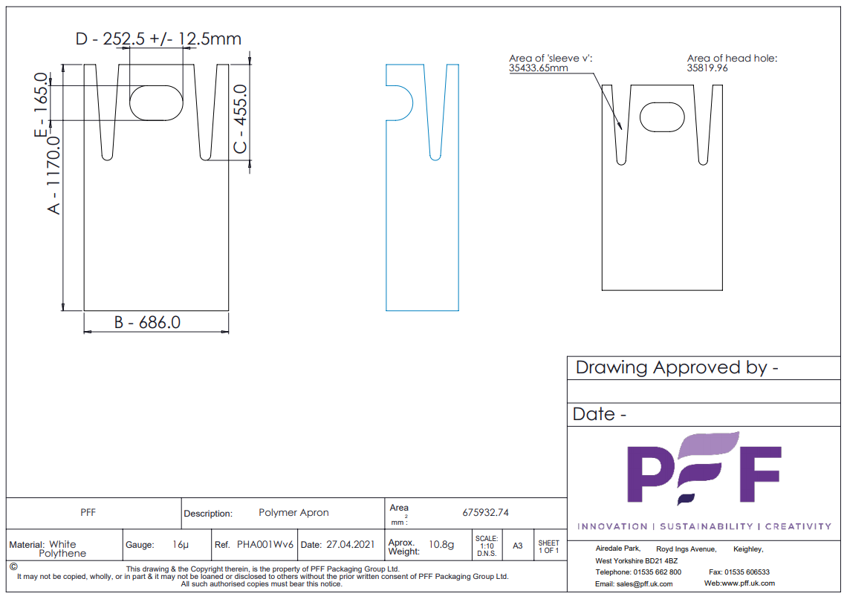

Signed: Signed:

Name: Kevin Maltby Name Kenton Robins

Position: Group Quality and Compliance Position: Managing Director

Manager

Date: 02/09/2021 Date: 02/09/2021

This declaration is valid for 5 years from date of issue.

[www.pff.uk.com/health](http://www.pff.uk.com/health)

T: +44 (0)191 415 6500

E: [sales@pff.uk.com](mailto:sales@pff.uk.com)

enquires@pffhealth.uk.com